Martina Vasco

00121723 (virtual tourist, 2013)

**Restaurant in Mindo**

In Mindo we find a lot of varities of restaurants, they willing to present a lot of varieties of food, with the best conditions and with the best prices.

**Restaurante Omarcito**

I cant exactly rave about this place. The food wasnt bad but it wasnt great either. I had churrasco like always and Rob had a ceviche. He said his ceviche was alright. This place was ok if there just isnt anything else.

**Breakfast at La Casa de Cecilia**

When in Mindo I ate breakfast at Casa de Cecilia every morning, except the last morning as the breakfast then was included at the place where I stayed. La Casa de Cecilia is a lovely place to have breakfast in. They have an open-air restaurant by a small river, surrounded by lush vegetation with flowers, birds and butterflies. It is a relaxed place with good breakfast.   The breakfast I ordered consisted of bread, eggs, fruits, juice, coffee, butter and jam. This breakfast was $3.50 (July 2012). Without fruits the breakfast was $2.50.

**Restaurante Las Cascadas de Mindo**

Restaurante Las Cascadas de Mindo is situated on Avenida Quito, not far from Parque Central. They have a very good Tucha de La Plancha (trout) which I can recommend. The trout was served with rice, patacones and vegetables. It was $6.75 (July 2012). The lemon juice was $1.50 and so was the passion fruit juice.   Sometimes they have a few tables on the pavement outside the restaurant, where you can sit and watch people go by.

**Lunch on Avenida Sucre**

One of the days in Mindo I ate lunch at a small restaurant on Avenida Sucre, west of Parque Central. I had seen they prepared some of the food on the grill outside the restaurant and went there to ask for almuerzo (a set lunch menu). They had set lunch menus and I first got the soup, which was good with lots of vegetables in it. The main course was chicken, rice, potatoes and cucumber. To drink there was a juice. The lunch was good and it was $2.50 (July 2012). Later day I got problems with the stomach, and I wonder if it was because of the lunch, but I’m not sure.

**Restaurant at Mariposas de Mindo**

After visiting Mariposas de Mindo I thought it would be good to eat something before starting the walk back to Mindo. I was a bit hungry and it looked peaceful to sit in the empty restaurant beside the garden for a while.  From the menu I ordered a sandwich with avocado, egg, tomatoes and cheese. It was served with French fries. To drink I had a fresh mango juice and on the glass they had put slices of melon. It all tasted very good, and the price was $7.76

**A German café (Oasia)**

Coming back from a long hike to the waterfalls I saw two people I had met the previous day when going to Mindo. They sat outside a small café and had just eaten German sausages with potato salad and recommended it. I was very hungry and decided to order the same, and to drink I had a strawberry batido (juice made with milk). The food and drink was $4.75 (July 2012) and it tasted very good.   I think the café/restaurant is called Oasis, but I’m not sure. It is a small place, south of Parque Central. They serve breakfast, salads, soups, homemade bread, German specialties and desserts.

**Restaurant Pablito**

After I had arrived to Mindo and left my luggage I went out to look for lunch. It was quite late but I hoped I would find a restaurant that still served the set lunch menu. Restaurant Pablito on the main street looked like a place that would have a set lunch menu so I went there, and yes I could have lunch.   In the soup there was very overcooked pasta, and on the main plate there were beans (which I don’t like), rice, plantains, fried fish and some tomatoes and onions. I have had many much better set lunches, but anyway I got some food and could continue to look around in Mindo. The lunch, including a juice, was $2.50

**Pizzeria Don Pan: Pizzeria**

The Pizza in Ecuador isnt like the pizza that we are used to in the States. They use alot more oregano. The cheese is different. The crust is different also. They dont really use pepperoni its more like a type of sausage. Well, this pizza here in Mindo was OK. nothing special to write home about but it was OK.  We got a large pizza for about $11.00 I didnt see another place around here that sold pizza.

**Restaurante El Chef: Lomo a la piedra**

The last time I came to Mindo I stoped here to eat and I discovered the best steak in all of Ecuador. Since then I have dreamed of the day that I would come back and try this steak again. So now 2007 I finally get back to Mindo and I head back to this place and ......They dont have steak today! UHHHHG! They did have steak for churrasco but not the Lomo a la piedra. So I had the churrasco and it was pretty good.   **Favorite Dish:** Lomo a la Piedra. (steak cooked ontop of a rock.) Thick piece of tender steak with just right seasoning and very juicy.

**Several nice restaurants in Mindo**

In Mindo there are several nice restaurants. The numbers of restaurants are quiet high, because the town gets many visitors from Quito at weekends. Some are located on the main street and some are in the other streets, so have a look around. There is even a pizzeria (as I recall it is located close to the football stadium). Many places serve grilled fish (trout).

[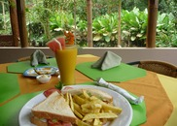](http://www.virtualtourist.com/travel/South_America/Ecuador/Provincia_de_Pichincha/Mindo-1588521/TravelGuide-Mindo.html)

[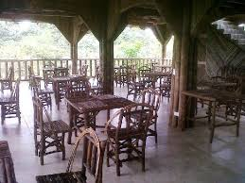](http://www.tripadvisor.cl/Hotel_Review-g609138-d866726-Reviews-San_Jorge_de_Milpe_Orchid_Reserve_Lodge-Mindo_Pichincha_Province.html)

[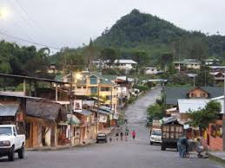](http://www.promocionesecuador.com/mindo-es-una-de-las-principales-atracciones-ecologicas-que-tiene-el-ecuador/)

[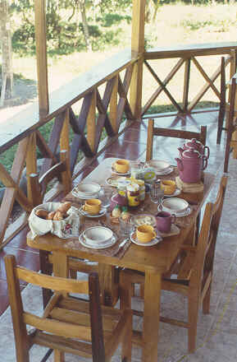](http://www.eldescanso.net/el_s.htm)

[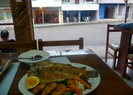](http://www.virtualtourist.com/travel/South_America/Ecuador/Provincia_de_Pichincha/Mindo-1588521/TravelGuide-Mindo.html)

[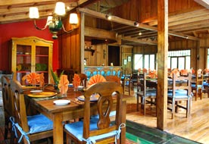](http://www.mindogardens.com/index.php?seccion=hosteria&archivo=hosteria&id=2)

(virtual tourist, 2013)

# Trabajos citados

*virtual tourist*. (14 de 10 de 2013). Recuperado el 14 de 10 de 2013, de http://www.virtualtourist.com/travel/South_America/Ecuador/Provincia_de_Pichincha/Mindo-1588521/Restaurants-Mindo-TG-C-1.html: http://www.virtualtourist.com/travel/South_America/Ecuador/Provincia_de_Pichincha/Mindo-1588521/Restaurants-Mindo-TG-C-1.html